Class 12 Biology Project (By Ms. Sonali)
Topics (Any one):1. Genetic disorders
2. DNA fingerprinting
3: Cancer
4. AIDS

LITERATURE PROJECT FOR STD XII (By Ms. Anita)
TOPIC-- Analyse the character of Ariel in the play “The Tempest’’. Subtopics to be covered. • Acknowledgement • About the author • Character of Ariel • Conclusion • Bibliography .
(Use single ruled ,thin,long register copy for the project. Cover it with yellow chart paper . Word limit 1200- 1500 words.)
Economics (By Mr. Suraj)
Public Sector
Study a Public sector enterprise with reference to its relation to Indian Economy and its future prospect. Analyze the trend of its growth for the last 5 years
1.Refer to your Economics textbook for guidelines. 2.Use practical sheets for doing your project
Physics (By Mr. Nazir)
1) Communication system . 2) Electronic devices . 3)Optical Instruments .4)Dual nature of radiation and matter . Students , you have to do project on any two topics
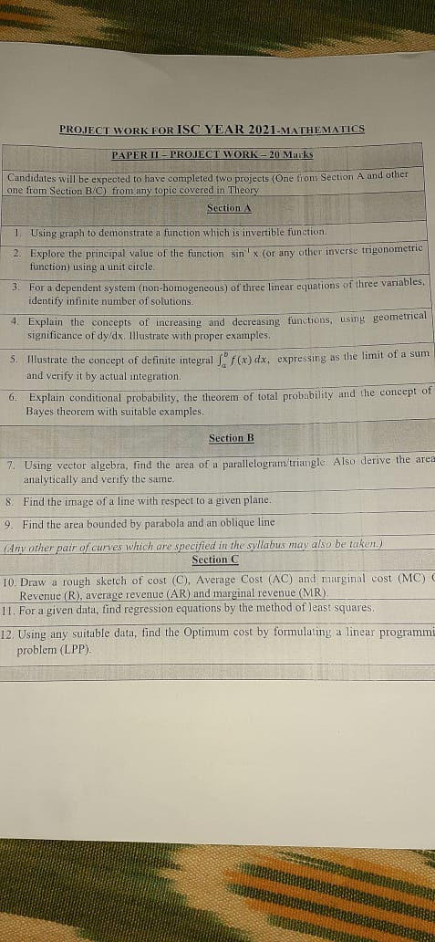
DE NOBILI SCHOOL MAITHON
COMPUTER PROJECT
ISC COMPUTER PROJECT-1(CLASS 12)
- Introduction to Boolean Algebra.
- Explain terms with examples:
i. Propositional logic
ii. Conditional
iii. Bi-conditional
iv. Truth Values
v. Contingencies
vi. Tautologies
vii. Contra dictions
- State and prove the follow Boolean laws with circuit diagram and truth table
Idempotence law
Complementarity law
Associative law
Distributive law
Absorption law
De-Morgan’s law
- Introduction to Logic Gates
Explain the following Gates using truth table and circuit diagram.
I. NOT II. AND III. OR IV. NAND V. NOR VI. XOR VII. XNOR Gate.
Definition of Universal Gates, draw circuit diagrams to develop AND, OR and
NOT gates by using only NAND and NOR gates only.
- Introduction to SOP and POS by using K-map and circuit diagrams.
I. Solve 3 SOP based problems-
Truth Table, K- map, circuit diagrams.
II. Solve 3 POS based problems -
Truth Table, K-map, circuit diagram.
- Conclusion (compulsory)

(Project work must be done in big size practical note -copy, leave first few pages of the copy and then start the project)

STD-12 SC Chemistry project topics

(1) Amino acids: peptide, structure and classification, proteins structure and their role in growth of living beings .

OR (2) Chemicals in medicine: antiseptic, antibiotics, antacid etc. and their uses.

OR (3) Natural polymers ( any five) - structure, characteristics, uses. Synthetic polymers (any five) : method of preparation, structure, characteristics and uses.

DE NOBILI SCHOOL, MAITHON
Project work for Accounts & Commerce Class: 12 Subject Project Topic COMMERCE
- Study the sources of recruitment and steps involved in the selection procedure adopted by two companies of the same industry. b) compare and evaluate the sources of recruitment and the selection process adopted by the selected companies.
- Accounts Preparation of a cash flow statement with the help of audited/unaudited/ imaginary balance sheets of a company for two consecutive accounting years or two consecutive quarters of an accounting year could be taken along with at least five additional information ( depreciation, purchase/sale of fixed assets, Divided paid/proposed, Tax paid/ proposed, amortization of intangible assets, profit or loss on sale of fixed assets including provision for depreciation on them and profit or loss on sale of investments). THE RESULTS OF EACH ACTIVITY COULD BE SHOWN GRAPHICALLY AND/ OR PICTORIALLY ( BAR DIAGRAMS AND PIE CHARTS)

