Std -12 Sc.
Topic – Biomolecules
1) Define the following terms:-
a) Glyosidic linkage
b) Peptide linkage
c) Mutarotation
d) Avitaminosis
e)Zwitter ion
f) Denaturation of proteins.
g) Invert sugar
h) Co- enzymes
i) Nucleic acid.
j) Oligosaccharides
k) Iso- electric point.
2) Give the difference between them :-
a) Nucleosides and Nucleotides.
b) DNA and RNA
c) Water soluble vitamin and fat soluble vitamin.
d) Fibrous Proteins and Globular Proteins.
e) Essential Amina acids and non-essential -Amina acids.
f) … Glucose and B –Glucose
g) 1⁰ str. Of protein and 2⁰ str. Of protein.
h) Cellulose and Glycogen.
i) Reducing sugar and non – reducing sugar.
j) Amylose and Amylopectin.
k) Starch and Cellulose.
3) Give reason :-
a) Why is cellulose not digested in human body ?
b) Why must vitamin C be supplied regularly in diet?
c) Amino acid are amphoteric in nature.
d) The M.P and solubility in water of Amino acids are generally higher than that of the corresponding halo acids?
e) Why sucrose is known as invert sugar?
f) Amylase present in the saliva becomes inactive in the stomach.
4) Give the answers of the following questions :-
a) Classify the RNA and give one function each of them.
b) Write such reactions and facts about glucose which cannot be explained by its open chain str.
c) What happens when D – Glucose is treated with the following reagents (a) HI, (b) Bromine water (c) HNO₃ (d) NH₂OH or HCN.
d) Give 4 functions of nucleic acid.
e) Give the composition of nucleic acid.
5) Give one word answer:-
a) Name the location where protein synthesise occurs in our body : - cytoplasm
b) Name water soluble vitamins and the deceases caused by it.
c) Write the name of the vitamin which are responsible for following deceases.
i) Sterility ii) Coagulation of blood iii) Haemophilia iv) Dermatitis v) Ariboflavinosis
vi) Xerophthalmia
6) Give an example of :-
a) Reducing sugar.
b) Non reducing sugar.
c) Purine base
d) Pyrimidines base
7) What are the by products are form due to the hydrolysis of – Sucrose, Lactose, Maltose, DNA and RNA.

Std -10
Assignment of acids bases and salts.
Part -3 (Salts)
Type -1
Define the following terms:
a) Neutralisation
b) Acids salts.
c) Basic salts.
d) Hydrolysis.
e) Water of crystallisation.
f) Efflorescence
g) Deliquescent substances
h) Hygroscopic substances
Type -2
Give the difference between following terms:-
a) Drying agents and Dehydrating agents(With example)
b) Efflorescence substances and deliquescent substances.
c) Normal salts and basic salts.( With example)
d) Salts and acids .( With example)
Type -3
Give reasons:-
i)Anhydrous Fecl₃ cannot be prepared by heating hydrated iron.
ii) Chloride.
iii) Anhydrous CaCl₂ is used in a desiccator.
iv) Fused CaCl₂ is used in the preparation of Fecl_{3 .}
v) Concentrated H₂ SO₄ gets diluted on exposure to air.
vi) Why is the direct addition of Sulphuric Acid to lead carbonate is not recommended for the preparation of lead sulphate.
vii) When exposed to air, Glauber’s salt loses mass, where as quick lime gains mass.
viii) Washing soda crystals became white powder when left exposed to air.
Type – 4
How are the following conversation carried out? Give balanced chemical equations only.
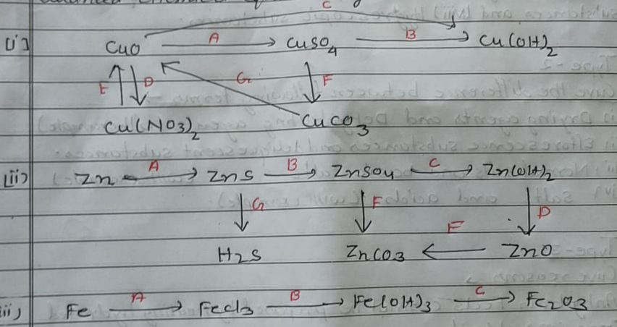
Type – 5
Give the answer of the following questions →
- Write the balanced chemical equation for the preparation of following salts
- A soluble sulphate by the action of an acid on an insoluble base.
- An insoluble salt by the action of an acid on another salt.
- An insoluble base by the action of a soluble base on a soluble salt.
- A soluble sulphate by the action of an acid on a metal
- Lead (II) chloride from led carbonate
- Potassium sulphate from KOH solution
- Name the method used for the preparation of following salts
- Sodium nitrate (ii) Iron (D) chloride (iii) Lead chloride
- Zinc sulphate (v) sodium hydrogen sulphate
Type – 6
Give one word answer / A suitable chemical term→
- A salt formed by incomplete neutralization of an acid by a base→
- A definite number of water molecules bond to some salts→
- A salt containing a metal ion surrounded by other ions or molicules.
- Name a crystalline salt which doesn’t contain water of crystallisation.
- A salt insoluble in cold water but soluble in hot water.
- A normal salt and an acid salt of the same acid
- Insoluble chloride
- An oxide which form salts when it reacts with both acid and alkalis.

